**SUMMER INTERNSHIP REPORT- 2023**

**BANARAS LOCOMOTIVE WORKSHOP**

**VARANASI(221004)**



**SUBMITTED TO-:**

**PRINCPAL OF**

**TECHNICAL TRAINING**

**CENTRE**

**VARANASI-(221004)**

**SUBMMITED BY-**

NAME - AKASH KUMAR YADAV

REGISTRATION NO. - 2023061347

TRAINING DURATION- 21-06-2023 TO 05-07-2023

COURSE - BTECH

BRANCH - COMPUTER SCINCE

& ENGINEERING

YEAR - 2020-24

COLLEGE NAME - LUCKNOW UNIVERSITY,

LUCKNOW (UP)

**DECLARATION**

We hereby declare that this submission is our own work and that, to the best of our knowledge and belief, it contains no material previously published or written by another person or material which to a substantial extent has been accepted for the award of any other degree or diploma of the University or other institute of higher education, except where due acknowledgement has been made in the text.

Signature -:

Name -: AKASH KUMAR YADAV

Reg. no. -: 2023061347

Date -:

**i**

**CERTIFICATE OF TRAINING**

This is to certify that Mr. Akash Kr. Yadav student of Bachelor of Technology in Computer Science & Engineering branch of **Lucknow University , Lucknow** has successfully completed 2 weeks of Industrial training in ‘EDP’ from 21/06/23 to 05/06/18. During the training he worked on project name Application of Artificial intelligence tools in "EDP" under the guidance of "Mr Teerth".

_________________________________________

Mr. Teerth DATE:

(Sr. Engg. (IT))

**ii**

**Contents:**

Page no.

Declaration i

Certificate ii

Abstract 1

Chapter 1 : Introduction to AI

* 1. Introduction 2
  2. Types of AI 3
  3. Advantages & Disadvantages of AI 4

Chapter 2 : AI Tools

2.1 Bill generator tool 5

2.2 Content summarizer tool 6

2.3 PDF summarizer tool 7

Conclusion 8

Reference 9

**Abstract**

Ideas (technologies) that seem unthinkable to a present generation often become conventional with time. Artificial Intelligence (AI), the idea that computers will eventually replicate humans as sensory beings is one such outlandish assertion. In the personal financial services arena, and investment decision-making process and portfolio management context, AI must contend with the inconvenient statistical truth that investment returns tend to revert to the mean; as well as what neural scientists and behaviorists have been studying in recent times (i.e., how to map and profile unique individual emotional patterns).

• Since a robust macro-econometric model must monitor and map as many as 2,000-3,000 dependent variables, but cannot incorporate the “soft” inputs of sentiment (behavior), policy and geopolitics, over the longer term won’t reversion-to-the-mean (less fees) be the best of the results one could expect?

• In today’s and the future online “robo” revolutionary world, what will be the impact of interactive AI-driven decision programs on the RIA-offered personal financial advisory business (profession)?

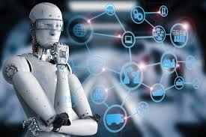

1

**CHAPTER 1: Introduction to AI**

* 1. **Introduction:**

In today's world, technology is growing very fast, and we are getting in touch with different new technologies day by day.

Here, one of the booming technologies of computer science is Artificial Intelligence which is ready to create a new revolution in the world by making intelligent machines.The Artificial Intelligence is now all around us. It is currently working with a variety of subfields, ranging from general to specific, such as self-driving cars, playing chess, proving theorems, playing music, Painting, etc.

AI is one of the fascinating and universal fields of Computer science which has a great scope in future. AI holds a tendency to cause a machine to work as a human.

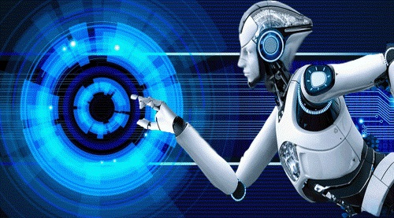

Artificial Intelligence is composed of two words **Artificial** and **Intelligence**, where Artificial defines *"man-made,"* and intelligence defines *"thinking power"*, hence AI means *"a man-made thinking power."*

So, we can define AI as:

 "It is a branch of computer science by which we can create intelligent machines which can behave like a human, think like humans, and able to make decisions."

**2**

Artificial Intelligence exists when a machine can have human based skills such as learning, reasoning, and solving problems

With Artificial Intelligence you do not need to preprogram a machine to do some work, despite that you can create a machine with programmed algorithms which can work with own intelligence, and that is the awesomeness of AI.

It is believed that AI is not a new technology, and some people says that as per Greek myth, there were Mechanical men in early days which can work and behave like humans.

**3**

* 1. **Types of AI :**

Artificial Intelligence can be divided in various types, there are mainly two types of main categorization which are based on capabilities and based on functionally of AI. Following is flow diagram which explain the types of AI.

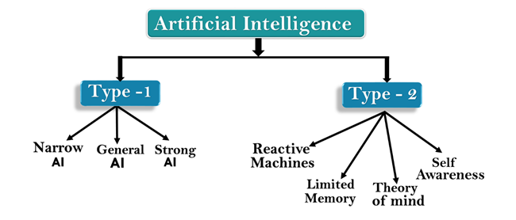

## AI type-1: Based on Capabilities

### 1. Weak AI or Narrow AI:

* Narrow AI is a type of AI which is able to perform a dedicated task with intelligence.The most common and currently available AI is Narrow AI in the world of Artificial Intelligence.
* Narrow AI cannot perform beyond its field or limitations, as it is only trained for one specific task. Hence it is also termed as weak AI. Narrow AI can fail in unpredictable ways if it goes beyond its limits.
* Apple Siriis a good example of Narrow AI, but it operates with a limited pre-defined range of functions.
* IBM's Watson supercomputer also comes under Narrow AI, as it uses an Expert system approach combined with Machine learning and natural language processing.
* Some Examples of Narrow AI are playing chess, purchasing suggestions on e-commerce site, self-driving cars, speech recognition, and image recognition.

**4**

### 2. General AI:

* General AI is a type of intelligence which could perform any intellectual task with efficiency like a human.
* The idea behind the general AI to make such a system which could be smarter and think like a human by its own.
* Currently, there is no such system exist which could come under general AI and can perform any task as perfect as a human.
* The worldwide researchers are now focused on developing machines with General AI.
* As systems with general AI are still under research, and it will take lots of efforts and time to develop such systems.

### 3. Super AI:

* Super AI is a level of Intelligence of Systems at which machines could surpass human intelligence, and can perform any task better than human with cognitive properties. It is an outcome of general AI.
* Some key characteristics of strong AI include capability include the ability to think, to reason,solve the puzzle, make judgments, plan, learn, and communicate by its own.
* Super AI is still a hypothetical concept of Artificial Intelligence. Development of such systems in real is still world changing task.

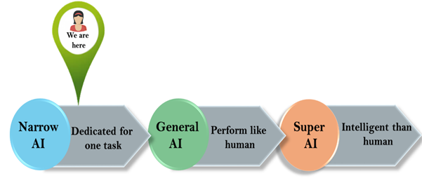

**5**

## Artificial Intelligence type-2: Based on functionality

### 1. Reactive Machines

* Purely reactive machines are the most basic types of Artificial Intelligence.
* Such AI systems do not store memories or past experiences for future actions.
* These machines only focus on current scenarios and react on it as per possible best action.
* IBM's Deep Blue system is an example of reactive machines.
* Google's AlphaGo is also an example of reactive machines.

### 2. Limited Memory

* Limited memory machines can store past experiences or some data for a short period of time.
* These machines can use stored data for a limited time period only.
* Self-driving cars are one of the best examples of Limited Memory systems. These cars can store recent speed of nearby cars, the distance of other cars, speed limit, and other information to navigate the road.

### 3. Theory of Mind

* Theory of Mind AI should understand the human emotions, people, beliefs, and be able to interact socially like humans.
* This type of AI machines are still not developed, but researchers are making lots of efforts and improvement for developing such AI machines.

### 4. Self-Awareness

* Self-awareness AI is the future of Artificial Intelligence. These machines will be super intelligent, and will have their own consciousness, sentiments, and self-awareness.
* These machines will be smarter than human mind.
* Self-Awareness AI does not exist in reality still and it is a hypothetical concept.

**6**

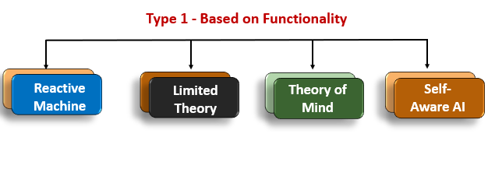

* 1. **Advantages & Disadvantages Of AI :**

### 1. Reduction in Human Error

One of the biggest advantages of Artificial Intelligence is that it can significantly reduce errors and increase accuracy and precision. The decisions taken by AI in every step is decided by information previously gathered and a certain [set of algorithms](https://www.simplilearn.com/tutorials/data-structure-tutorial/what-is-an-algorithm). When programmed properly, these errors can be reduced to null.

#### Example:

An example of the reduction in human error through AI is the use of robotic surgery systems, which can perform complex procedures with precision and accuracy, reducing the risk of human error and improving patient safety in healthcare.

### 2. Zero Risks

Another big advantage of AI is that humans can overcome many risks by [letting AI robots](https://www.simplilearn.com/tutorials/artificial-intelligence-tutorial/humanoid-robots) do them for us. Whether it be defusing a bomb, going to space, exploring the

deepest parts of oceans, machines with metal bodies are resistant in nature and can survive unfriendly atmospheres. Moreover, they can provide accurate work with greater responsibility and not wear out easily.

#### Example:

One example of zero risks is a fully automated production line in a manufacturing facility. Robots perform all tasks, eliminating the risk of human error and injury in hazardous environments.

### 3. 24x7 Availability

There are [many studies](https://www.cnbc.com/2019/11/17/67percent-of-workers-say-spending-too-much-time-in-meetings-distracts-them.html) that show humans are productive only about 3 to 4 hours in a day. Humans also need breaks and time offs to balance their work life and personal life. But AI can work endlessly without breaks. They think much faster than humans and perform multiple tasks at a time with accurate results. They can even handle tedious repetitive jobs easily with the help of AI algorithms.

#### Example:

An example of this is online customer support chatbots, which can provide instant assistance to customers anytime, anywhere. Using AI and natural language processing, chatbots can answer common questions, resolve issues, and escalate complex problems to human agents, ensuring seamless customer service around the clock.

### 4. Digital Assistance

Some of the most technologically advanced companies engage with users using digital assistants, which eliminates the need for human personnel. Many websites utilize digital assistants to deliver user-requested content. We can discuss our search with them in conversation. Some chatbots are built in a way that makes it difficult to tell whether we are conversing with a human or a chatbot.

#### Example:

We all know that businesses have a customer service crew that must address the doubts and concerns of the patrons. Businesses can create a chatbot or voice bot that can answer all of their clients' questions using AI.

Related Reading: [Top Digital Marketing Trends](https://www.simplilearn.com/online-digital-marketing-trends-article)

### 5. New Inventions

In practically every field, AI is the driving force behind numerous innovations that will aid humans in resolving the majority of challenging issues.

For instance, recent advances in [AI-based technologies](https://www.simplilearn.com/how-ai-and-automation-are-changing-the-nature-of-work-article) have allowed doctors to detect breast cancer in a woman at an earlier stage.

#### Example:

Another example of new inventions is self-driving cars, which use a combination of cameras, sensors, and AI algorithms to navigate roads and traffic without human intervention. Self-driving cars have the potential to improve road safety, reduce traffic congestion, and increase accessibility for people with disabilities or limited mobility. They are being developed by various companies, including Tesla, Google, and Uber, and are expected to revolutionize transportation.

## Disadvantages of Artificial Intelligence

### 1. High Costs

The ability to create a machine that can simulate human intelligence is no small feat. It requires plenty of time and resources and can cost a huge deal of money. AI also needs to operate on the latest hardware and software to stay updated and meet the latest requirements, thus making it quite costly.

### 2. No Creativity

A big disadvantage of AI is that it cannot learn to think outside the box. AI is capable of learning over time with pre-fed data and past experiences, but cannot be creative in its approach. A classic example is the bot Quill who can write [Forbes earning reports](https://www.forbes.com/sites/narrativescience/2015/10/12/eps-estimates-down-for-j-m-smucker-in-past-month/?sh=655a16097595). These reports only contain data and facts already provided to the bot. Although it is impressive that a bot can write an article on its own, it lacks the human touch present in other Forbes articles.

### 3. Unemployment

One application of artificial intelligence is a robot, which is displacing occupations and increasing unemployment (in a few cases). Therefore, some claim that there is always a chance of unemployment as a result of chatbots and robots replacing humans.

For instance, robots are frequently utilized to replace human resources in manufacturing businesses in some more technologically advanced nations like Japan. This is not always the case, though, as it creates additional opportunities for humans to work while also replacing humans in order to increase efficiency.

### 4. Make Humans Lazy

[AI applications](https://www.simplilearn.com/tutorials/artificial-intelligence-tutorial/artificial-intelligence-applications) automate the majority of tedious and repetitive tasks. Since we do not have to memorize things or solve puzzles to get the job done, we tend to use our brains less and less. This addiction to AI can cause problems to future generations.

### 5. No Ethics

Ethics and morality are important human features that can be difficult to incorporate into an AI. The rapid progress of AI has raised a number of concerns that one day, AI will grow uncontrollably, and eventually wipe out humanity. This moment is referred to as the AI singularity.

**Chapter 2 : AI Tools**

**2.1 Bill for sale generator tool –**

In today’s life whenever we doing shopping or placing order , we need a bill as a proof .

The bill is containing important information like –

* Senders detail
* Shop details
* Items
* Rate of particular items
* Quantity
* Amount
* Total amount
* Payment method

So, Bill for sale generator is an artificial intelligence tools which is generating bill in proper format for any kind of shopping .

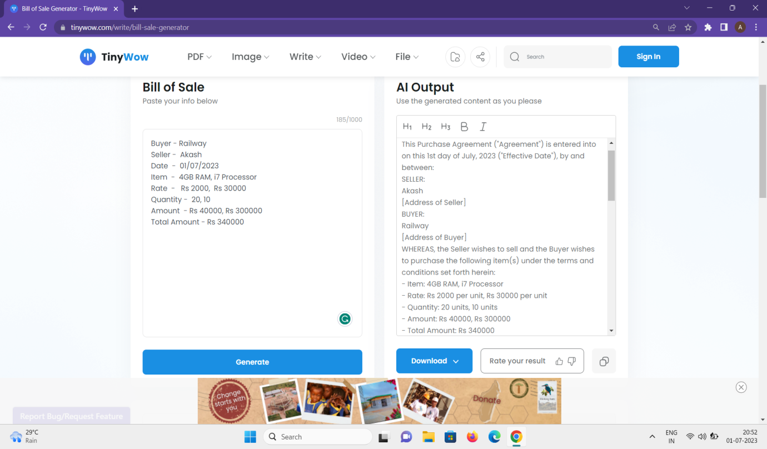

**2.2 Content Summarizer AI tool :**

An AI summarizer is a tool that uses [artificial intelligence](https://fireflies.ai/blog/top-ai-trends-in-2023/) techniques to condense or summarize large volumes of content into shorter, more concise versions.

It automatically analyzes the content, identifies key information, and generates a summary that captures the essence of the original content.

AI summarizers have applications in various domains, such as wordy articles, research papers, YouTube videos, lengthy lectures, meetings, etc.

There are some content summarizing tool presents-:

* Jasper ai
* Content summarizer ai
* Fireflies.ai
* Vowel AI
* Eightify
* Summarize.tech

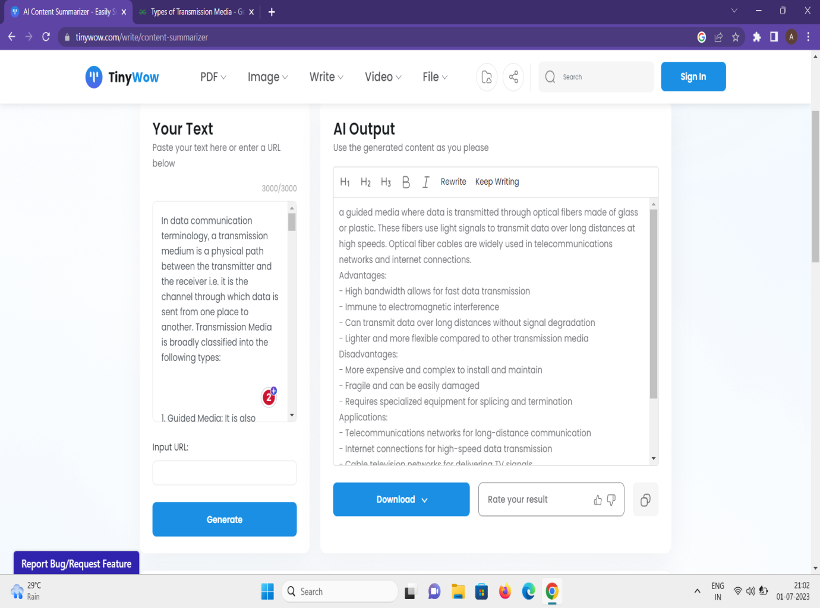

**2.3 PDF Summarizer AI tool**

A PDF summarizer is a tool or software that automatically generates concise summaries of PDF documents. It analyzes the content and extracts key information to provide a condensed version of the document's main points.

They typically use natural language processing (NLP) techniques and Artificial Intelligence (AI) to understand the text and extract relevant information. PDF summarizers employ algorithms to identify important sentences, key phrases, or significant sections and generate a summary that captures the essence of the document.

* IntelliPPT
* Summarizer.org
* Get Digest
* Scholarcy

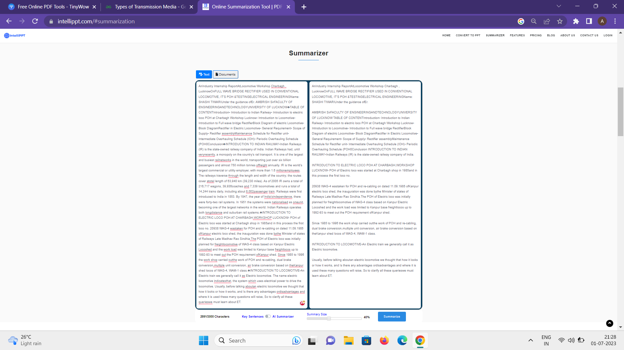

**Conclusion :**

* By the use of Artificial intelligence tool our work get easier .
* By the use of Artificial intelligence tool work efficiency is also increase.
* Artificial intelligence reducing the error.
* Artificial intelligence reduce the time.

**Reference**

Google

* <https://tinywow.com/>
* <https://www.intellippt.com/>

Books

* Artificial intelligence – a Modern Approach (3rd edition)
* Artificial intelligence engineering : A tutorial introduction to mathematics of deep learning